HealthPartners
Rating Service Requirements

Rating Service

Version Draft

12/22/2016

Contents
1. GENERAL 3
1.1. Project Description 3
1.1.1. Background 3
1.1.2. Purpose 3
1.1.3. Assumptions and Constraints 4
1.1.4. Interfaces to External Systems 4
1.2. Points of Contact 5
1.3. Document Reference 5
2. FUNCTIONAL REQUIREMENTS 5
3. OPERATIONS REQUIREMENTS 9
3.1. Security 9
3.2. Audit Trail 9
3.3. Data Currency 10
3.4. System Availability 10
3.5. System Reliability 10
3.6. Performance 10
3.7. Capacity 11
4. GLOSSARY 11

GENERAL

Project Description

Background
Currently there are several applications that serve up rates to users. Each application uses its own method to calculate the rates. This causes extra work and potential error.

Purpose
The project will create a common web service that allows multiple applications to request rates from a common source. This will improve the following
  - Maintenance of rates. There will only one source for rates for all applications maintained by the M&SS team. This will improve the ability to introduce new rates speedily cutting the overall time in take to disseminate and test new rates.
  - Ability to audit access to the rate container.
  - Increased Security.

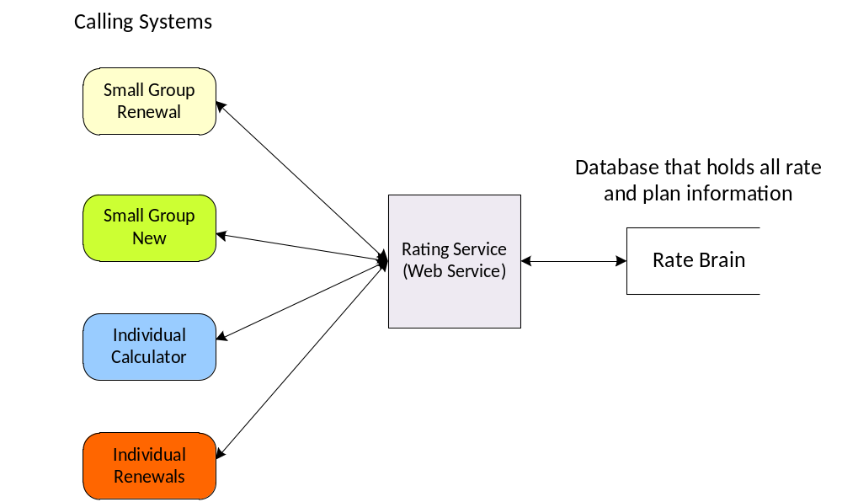

Diagram 1 – Context View for Rating Service. Not all of the Processes that will use the new rating service have been listed.

Assumptions and Constraints
- Individual quoting through IA will not use the new Rating Service. Rates will still have to be loaded into IA when new rates are published.
- Rating Service will be used for 2017 rates and newer.
- The Service will be used not be used for Medicare Rates.
- We will not rate as billed rates only base rates.
- Group Dental will need to be looked at closer. Currently this is not in the Rate Brain database.
- Short Term yes or no.

Interfaces to External Systems
N/A

Points of Contact

Name | Role on Project | Contact Info
Mark Schwob | Project Sponsor
Neil Turner | Business Analyst
Christopher Nelson | Developer
Karen Nuessmeier | Developer

Document Reference
List of documents that have been used to produce the ERD, could also include any meeting minutes that have been produced and saved.

FUNCTIONAL REQUIREMENTS

2.1 Functional Process Requirements

Requirement Number | Requirement
R1 | The service needs to deliver rates for all small group medical, small group dental, individual medical and individual dental plans for a given contract.
R2 | The service needs to deliver rates for all small group medical, small group dental, individual medical and individual dental plans for a given census.
R3 | If any of the parameters is invalid then an error code and error text will be passed back to the calling application. See Exception table for a more complete list of exceptions.
R4 | If contract is not sent then at least one census member must be populated. See Exception detail for more details.
R5 | If contract is sent then all members on that contract will be rated.
R6 | If no rates are available for the effective date then an error code and error text will be sent back to the calling application. See Exception
R7 | An indication if a census member is billable or not will be passed back to the calling application.
R8 | A rate will be passed back for all census members even if they are not billable.
R9 | The Integration will be synchronous in nature. The call application will wait for the rate service to supply results.

List of Exceptions that will be passed back to the calling application.

Type | Coverage Type | Reason
Error | All | Package code not found
Error | All | Rates for effective date not available
Error | All | No census members or contract
Error | All | A billable member has a rate of $0
Error | All | Total rate of $0
Error | All | Effective date in the past (may be removed from list of errors)
Error | All | Member’s birth date is after the effective date
Error | All | Internal error – support has more detail
Error or Warning | Small Group Medical | Census Members missing data (Tobacco / Gender used in rating
Error or Warning | Small Group Medical | Package Code and current corporation for group does not match – This occurs when a group/contract presented and current data does not match existing data
Error or Warning | Small Group Medical | Package Code not available for known address – occurs only when group/contract presented and current data does not match existing date.
Warning | Small Group Medical | Only one family with dependents.
Warning | Small Group Medical | Family has more than 9 dependents
Warning | Small Group Medical, Individual Medical | One of the census members is over 65
Warning | All | Field for determining rate not present in Census
Warning | All | Rates are pending activation. We should not display these to the wider world.

2.2 Data Requirements

Objects to pass in are:

When we know the contract and want to rate for members in that contract.

Attribute | Required | Description/Use
Pkg_cd | Yes
Contract | Yes
Effective Date | Yes
Census | No | List of census objects.

When we have a known census but we either don’t know the contract or they don’t have a contract.

Attribute | Required | Description/Use
Pkg_cd | Yes
Effective Date | Yes
Network | No | This is required for small group for 2017 plans
Census | Yes | Array of census objects. See census for attributes.
Effective Date | Yes
Birthdate | Yes

Census object

Attribute | Required | Description/Use
Age | Yes
Sex | No
Smoking | No | If smoking is not indicated we should default to Non smoking
County | Yes | Used to calculate rate area
Relationship | Yes

Objects passed back from the service.

Attribute | Required | Description/Use
Census Rates | Yes | For each member in the census or contract a census rate object will be returned.
Total Rate | Yes | A Total rate for the contract or entered census

Census Rate Object

Attribute | Required | Description/Use
Rate | Yes | For each member in the census or contract a rate will be returned.
Member ID | No | If a contract is passed in then this will be populated.
Is Billable Flag | Yes | If the census member can be billed then this flag will be set to ‘Y’ else it will be set to ‘N’

Age Banded Rates
A complete set of age bands will be passed back.

Attribute | Required | Description/Use
Min Age | Yes
Max Age | Yes
Gender | No
Non Tobacco Rate | Yes
Tobacco Rate | Yes
Tobacco factor | Yes
Rate Band Type | Yes | (A = Age Band, D = Dependent Rate)

OPERATIONS REQUIREMENTS

Security
The service must be developed to handle HTTPS calls. All other security requirements will be handled by the calling application.

Audit Trail

Requirement Number | Requirement
A1 | Each transaction received must be recorded. See below for what should be recorded.
A2 | Each response must be recorded. See below for what should be recorded.
A3 | We must be able to identify which response belongs to which request easily.
A4 | The Rates for each Census must be easily identifiable.

Each transaction will be recorded and the information available if required. The following will be recorded

Request Transaction
- Date/Time of request(MM/DD/YYYY HH:MM:SS)
- Calling Application
- Pkg_Code
- Network
- Effective Date
- Contract Id
- Census (Age, Sex, Smoking, County, Relationship), One record for each census member
- Relationship

Response Transaction
- Date/Time of response(MM/DD/YYYY HH:MM:SS)
- Census (Rate, Is Billable Flag, Member Id) – One for each census member sent
- Total Rate

Data Currency
Data has be delivered real time.

System Availability

The System needs to be designed and developed to have a high availability during the standard work day. If the system is not available then all small group quoting and proposals will be delayed. During off hours it would be desirable to have the service still available for calling applications to use. There will be some downtime where rates will not be available.

The requests for rates does rely on Membership information being available, this occurs out of hours and during this time rating will be unavailable.

System Reliability
The service must be reliable as the majority of sales quotes will transpire through the Rating Service. If the service is not reliable all Small Group sales, renewals and individual renewals will be effected.

Performance

- The Service will be real time. There should be minimal delay in returning results to the calling application.
- Throughput. The Service should be able to handle Several thousand requests and hour
- Expected volume of data. The Service should be able to handle a Small Group Quote. This could contain up to a 1000 census members.
- Expected volume of user activity. Should be able to handle several thousand requests in a day.

Capacity
The Service will be able to provide rates for all active plans. The only limiting factor is if rates have not been defined for a given effective date.

GLOSSARY

